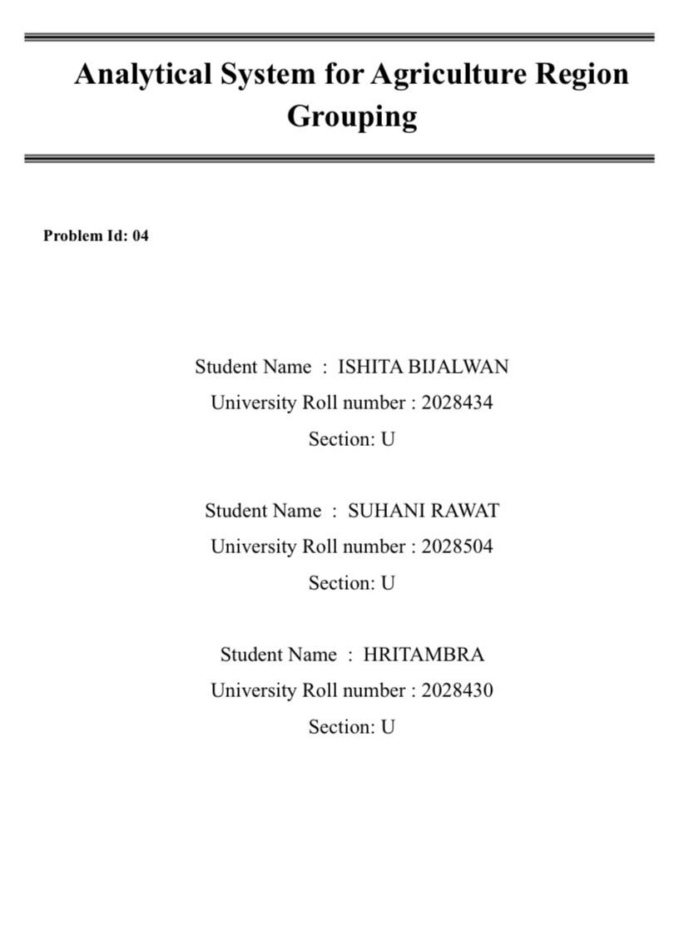

- Problem Description

Agriculture varies widely across regions due to differences in environmental conditions and resource availability. Factors like rainfall, temperature, soil quality, and farming practices directly impact crop productivity. However, analyzing these multiple factors together to identify meaningful patterns is difficult using traditional methods.
This project aims to solve that problem by developing a data-driven system using K-Means clustering. The goal is to group agricultural regions based on similarities in crop yield and environmental characteristics. By doing this, regions with similar conditions and productivity patterns can be identified.
The system will first analyze the dataset to understand distributions and relationships between features. Then, it will clean and normalize the data to ensure fair comparison. After selecting the most relevant features, clustering will be applied to divide regions into meaningful groups.
Finally, the results will help in better understanding agricultural patterns, improving decision-making, and predicting cluster categories for new regions. This makes the system useful for planning, resource allocation, and improving crop yield strategies.

  - Dataset Description

The dataset used in this project is an agriculture-based dataset (agri_dataset.csv), designed to analyze and group different farming conditions using machine learning techniques. It is a multivariate dataset containing approximately 20 numerical features, each representing a specific agricultural, environmental, or soil-related parameter.

Nature of the Dataset:
- Type: Structured (Tabular Data)
- Format: CSV (Comma-Separated Values)
- Data Type: Mostly numerical values
- Number of Features: ~20 input variables
- Target Variable: Not predefined (unsupervised learning is applied)
- Rows: Each row represents a unique agricultural observation/sample

Feature Description
Although exact column names are not explicitly shown, based on preprocessing and clustering steps, the dataset includes features related to:
1. Soil Characteristics
These features describe the physical and chemical properties of soil:
- Soil pH level
- Nutrient content such as Nitrogen (N), Phosphorus (P), Potassium (K)
- Soil fertility index
- Organic matter content
These factors are important because they directly affect crop growth and yield.

2. Environmental Conditions
These features represent climatic conditions affecting agriculture:
- Temperature
- Humidity
- Atmospheric pressure (if present)
- Seasonal variations
These variables help in understanding how climate impacts farming patterns.

3. Water-Related Parameters
- Rainfall levels
- Irrigation availability
- Soil moisture content
These are crucial for determining crop suitability and irrigation needs.

4. Crop and Yield Indicators
- Crop productivity or yield-related values
- Growth indicators
- Possibly crop type encoding (if included)
These features help analyze agricultural performance.

5. Other Agricultural Metrics
- Fertilizer usage
- Land quality indicators
- Additional derived indices

1.2 Flow Diagram

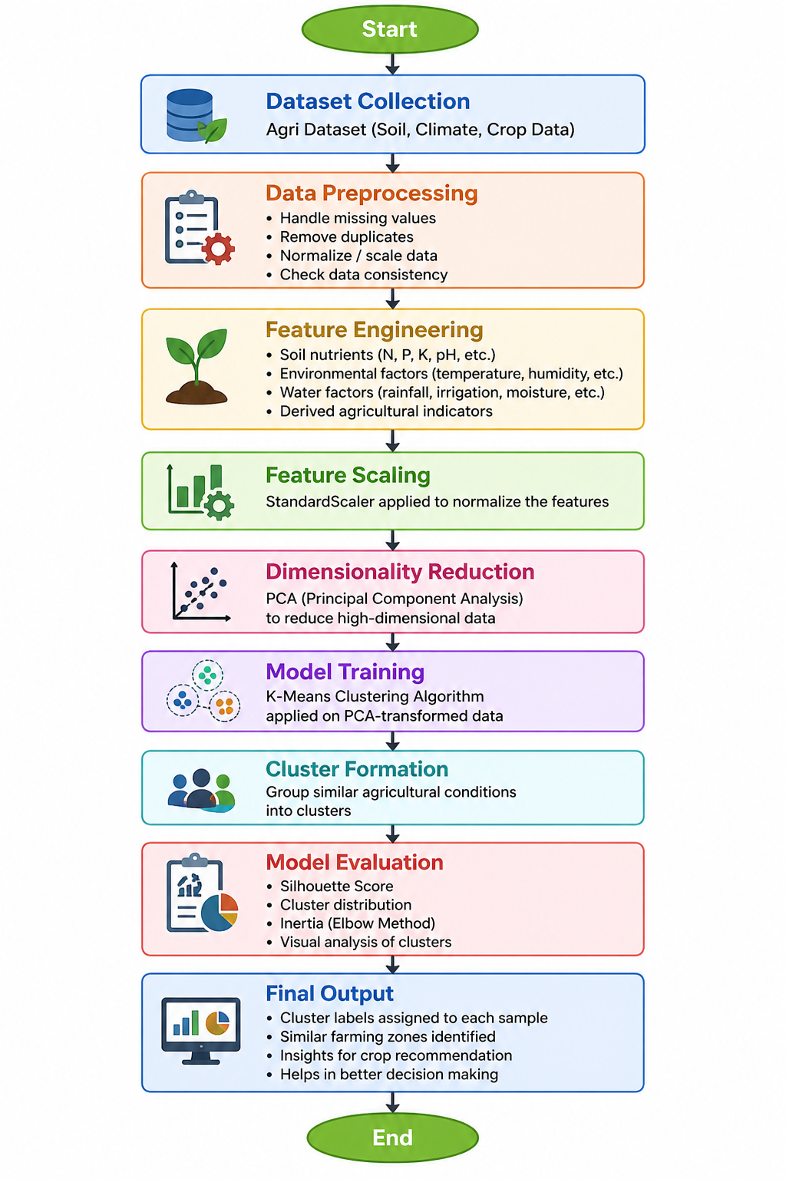
2. Modules for Project Implementation
2.1 Modules Used

1. Pandas
Functions used:
- pd.read_csv() – To read the dataset from CSV file into a DataFrame
- df.head() – To display first few rows of dataset
- df.describe() – To generate statistical summary
- df.isnull().sum() – To check missing values

2.NumPy
Functions used:
- np.array() – To create arrays
- np.mean() – To calculate mean
- np.std() – To calculate standard deviation

3. Matplotlib
Matplotlib is used for data visualization.
Functions used:
- plt.scatter() – To create scatter plots
- plt.plot() – To plot graphs
- plt.xlabel() / plt.ylabel() – To label axes
- plt.title() – To add title
- plt.show() – To display plots

4. Seaborn
Seaborn is used for advanced visualization and heatmaps.
Functions used:
- sns.heatmap() – To create heatmap for correlation
- sns.pairplot() – To visualize relationships between variables

5. Scikit-learn (sklearn)
Scikit-learn is used for machine learning tasks like scaling, PCA, and clustering.
a) Preprocessing Module
Functions used:
- StandardScaler() – To normalize the dataset
- fit_transform() – To fit and transform data
b) Decomposition Module
Functions used:
- PCA() – To reduce dimensions
- fit_transform() – To apply PCA
c) Clustering Module
Functions used:
- KMeans() – To apply K-Means clustering
- fit() – To train model
- predict() – To assign clusters
- fit_predict() – To fit and predict clusters
d) Metrics Module
Used for evaluating clustering performance
Functions used:
- silhouette_score() – To measure cluster quality

6. Custom Logic / Code Module
Custom code is used to integrate all steps of the pipeline.
Functions used:
- Data cleaning logic
- Feature selection logic
- Cluster labeling
- Visualization integration

2.2 Platform Used:

The following platforms are used for the development and implementation of the project:

• Visual Studio Code
Used for code writing, testing, and debugging.
VS Code provides a user-friendly interface with multiple extensions, syntax highlighting, and an inbuilt debugger, which enhances the overall development experience.

• Jupyter Notebook
Used for data analysis and model development.
Jupyter allows step-by-step execution of code, making it easier to visualize outputs like graphs and intermediate results. It is very helpful for data preprocessing, clustering, and visualization tasks.

• Python
Used as the programming language for implementing the project.
Python is preferred because of its simplicity and powerful libraries like Pandas, NumPy, and Scikit-learn for data analysis and machine learning.

- Machine Learning Model/ Searching Technique Used

In this project, unsupervised machine learning techniques are used to analyze and group agricultural data based on similarities in soil, environmental, and crop-related features. The primary model used is K-Means Clustering, supported by Principal Component Analysis (PCA) for dimensionality reduction and additional techniques such as the Elbow Method and Silhouette Analysis for model optimization and evaluation.
K-Means Clustering is an unsupervised learning algorithm that partitions the dataset into a predefined number of clusters. It works by initializing K centroids and assigning each data point to the nearest centroid based on distance. The centroids are then updated iteratively until the cluster assignments stabilize. This model is used in the project to group similar agricultural conditions together, allowing the identification of patterns such as similar soil properties, climate conditions, and productivity levels. It is chosen because of its simplicity, efficiency, and suitability for large numerical datasets.
Principal Component Analysis (PCA) is used as a dimensionality reduction technique to simplify the dataset while retaining the most important information. It transforms the original high-dimensional data into a smaller set of principal components that capture the maximum variance in the dataset. In this project, PCA helps in reducing computational complexity, improving clustering performance, and enabling effective visualization of clusters in two or three dimensions.
The Elbow Method is used as a searching technique to determine the optimal number of clusters for the K-Means algorithm. It involves running the clustering algorithm for different values of K and calculating the inertia, which represents the within-cluster sum of squares. The results are plotted on a graph, and the point where the curve shows a sharp bend (resembling an elbow) is selected as the optimal number of clusters. This ensures that the model does not underfit or overfit the data.
Silhouette Analysis is used to evaluate the quality of clustering. It measures how similar a data point is to its own cluster compared to other clusters, with values ranging from -1 to 1. A higher silhouette score indicates better-defined and well-separated clusters. In this project, it is used to validate the effectiveness of the clustering results and ensure meaningful grouping of agricultural data.

- Evaluation Metrics Used
In this project, several evaluation metrics are used to assess the performance and quality of the clustering model. Since the project is based on unsupervised learning, traditional accuracy measures are not applicable. Instead, metrics such as Silhouette Score and Inertia (Within-Cluster Sum of Squares) are used to evaluate how well the data has been clustered.

The Silhouette Score is used to measure how similar a data point is to its own cluster compared to other clusters. It helps in understanding the compactness and separation of clusters. The value of the silhouette score ranges from -1 to 1, where a value close to 1 indicates that the data point is well matched to its own cluster and poorly matched to neighboring clusters. A value close to 0 indicates overlapping clusters, and a negative value suggests incorrect clustering.

Within-Cluster Sum of Squares (WCSS). It measures how closely the data points in a cluster are grouped around the centroid. Lower values of inertia indicate better clustering as the points are closer to their respective cluster centers.

Elbow Method is used as a visual evaluation technique to determine the optimal number of clusters. It involves plotting the number of clusters (K) against the inertia values and identifying the point where the rate of decrease sharply changes, forming an “elbow.” This point indicates the most suitable number of clusters for the dataset.

5. Results and Visualizations
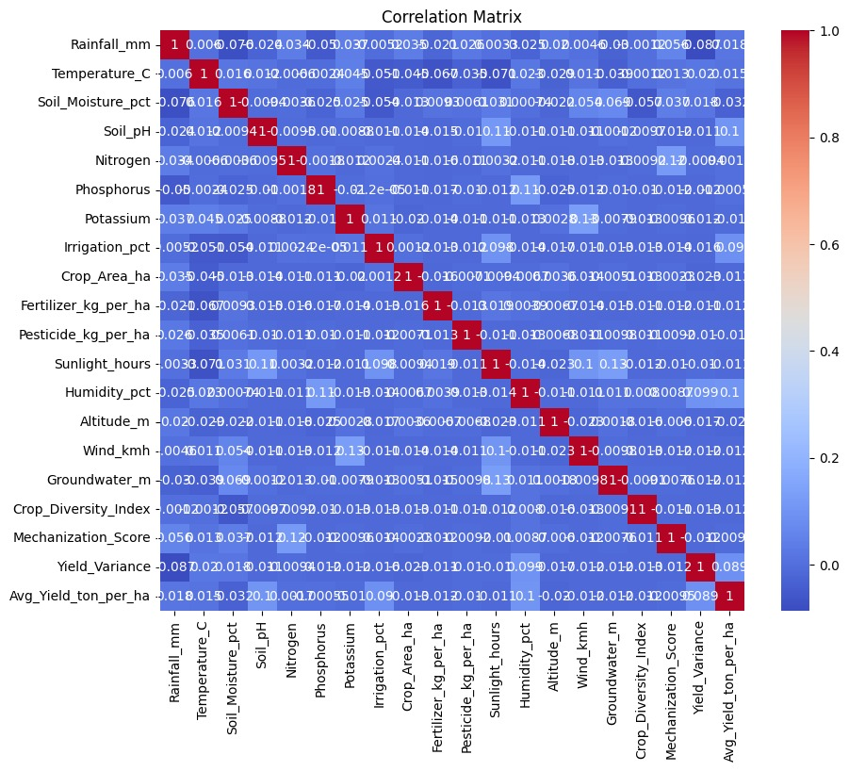
HEATMAP SHOWING COORELATION
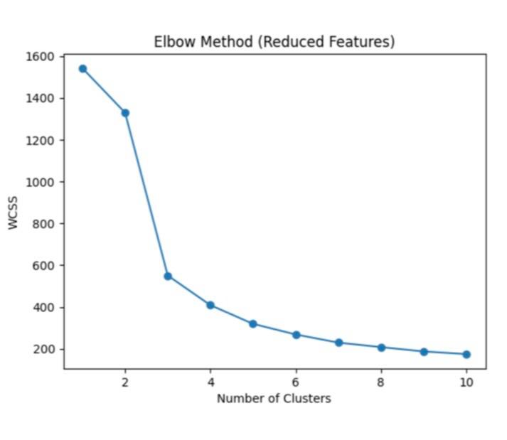

6. Conclusion and Future Scope:

This project focuses on analyzing agricultural data using unsupervised machine learning techniques to identify meaningful patterns and group similar farming conditions. By applying data preprocessing, feature scaling, and dimensionality reduction using Principal Component Analysis (PCA), the dataset was transformed into a suitable form for clustering. The K-Means clustering algorithm was then used to group the data into distinct clusters based on similarities in soil properties, environmental conditions, and other agricultural factors. The results were visualized using plots and heatmaps, making it easier to interpret the patterns present in the data.
The evaluation of the model using metrics such as Silhouette Score and Inertia ensured that the clusters formed were well-defined and meaningful. Overall, the project successfully demonstrates how machine learning can be used to extract useful insights from agricultural data, which can support decision-making in areas such as crop selection, soil management, and resource optimization.
In the future, this project can be further enhanced by incorporating larger and more diverse datasets to improve the accuracy and generalization of the model. Advanced machine learning algorithms such as DBSCAN or Hierarchical Clustering can be explored to compare performance and handle complex data distributions. Additionally, integrating real-time data from sensors and weather forecasting systems can make the model more dynamic and applicable in real-world scenarios. The system can also be extended to provide automated crop recommendations and integrated into a user-friendly application or dashboard for farmers and agricultural experts.
Overall, the future scope of this project lies in making it more scalable, intelligent, and practical for real-world agricultural applications, thereby contributing to the development of smart farming solutions.

